Contents

Prometheus 2

Introduction 2

Installation 2

Architecture 3

Basic Query 4

Monitor Java Application 4

Alert Manager 6

Grafanna 7

# Prometheus

<https://www.onemodel.app/d/LT3woBf1udw4S1Ze8jz5f>

## Introduction

<https://github.com/devopscert202/monitoringlogging>

<https://github.com/devopscert202/monitoringlogging/blob/main/intro_to_monitoring_observability.md> - Need of Monitoring

<https://github.com/devopscert202/monitoringlogging/blob/main/intro_to_prometheus.md>

Prometheus uses a pull method which pulls info from servers.

Prometheus is data collection which is not in UI and only in console. Grafanna can visualize data from Prometheus.

Prometheus has feature that if anyone modifies the config file, will be alert to other users.

## Installation

Prometheus can be in a different server, Graffanna in a different server and

<https://github.com/devopscert202/monitoringlogging/blob/main/labs/additional/prometheus_arm64_install.md> - how to install.

sudo systemctl start prometheus

sudo systemctl stop prometheus

sudo systemctl status prometheus – check the status

The below text box has lots of options and can select some option and click Execute

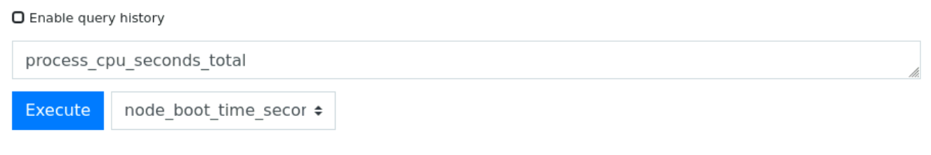

Click Graph to show in Graphical view.

<http://localhost:9090/metrics> - Will provide default metrics.

Its coming from default settings.

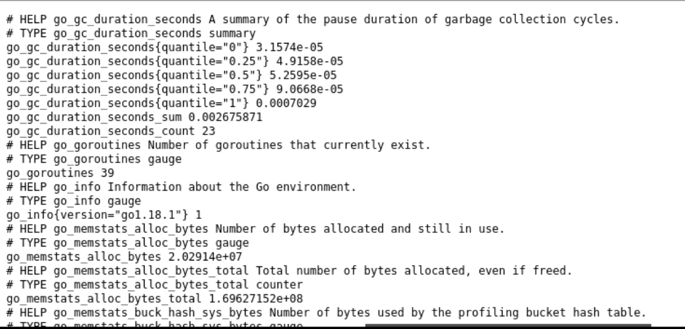

## Architecture

<https://github.com/devopscert202/monitoringlogging/blob/main/prometheus_architecture.md>

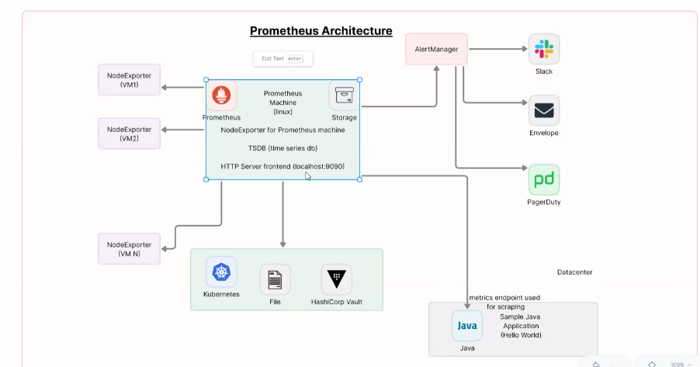

If there are 100 systems, need 100 different node exporter As node exported to be installed all the servers which we need Prometheus to monitor.

## Basic Query

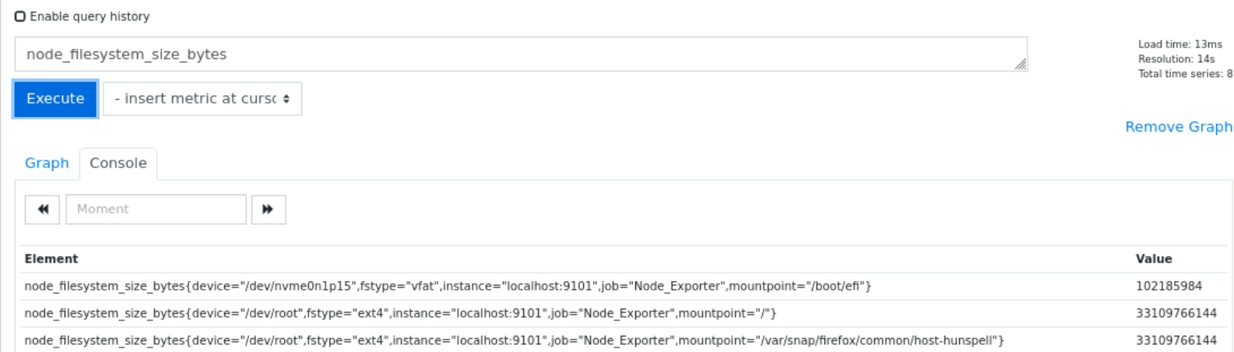

While writing query, it limits

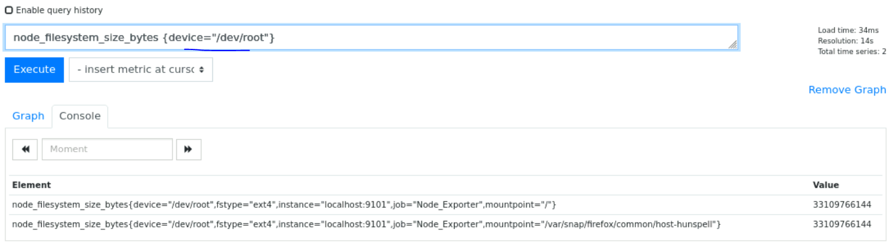

For any matching criteria, we can add multiple conditions.

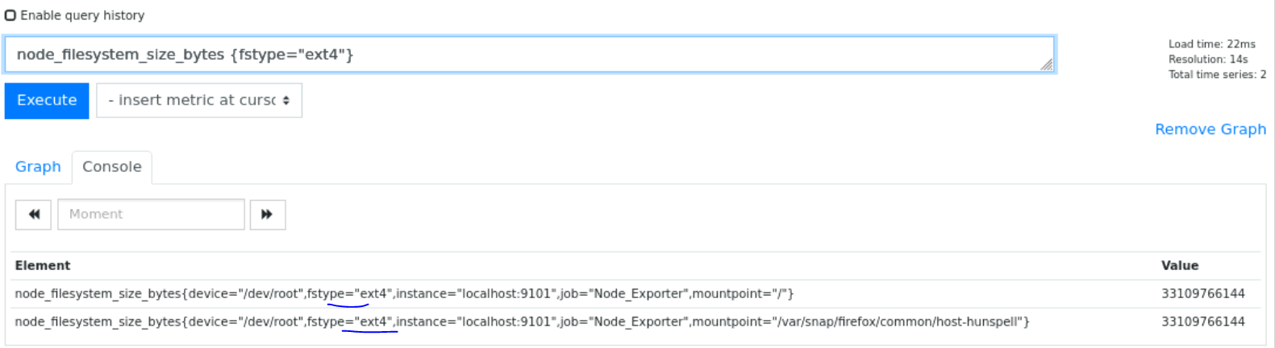

<https://github.com/devopscert202/monitoringlogging/blob/main/labs/promql_queries.md>

## Monitor Java Application



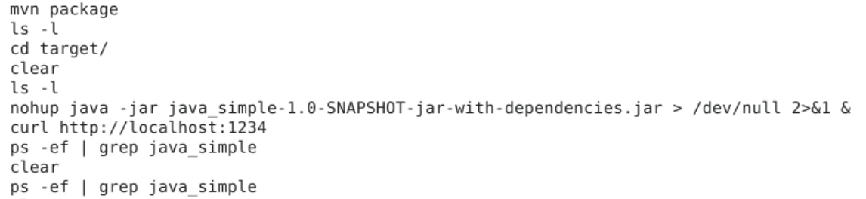

On typing curl <http://localhost:1234/metrics> will show the JVM

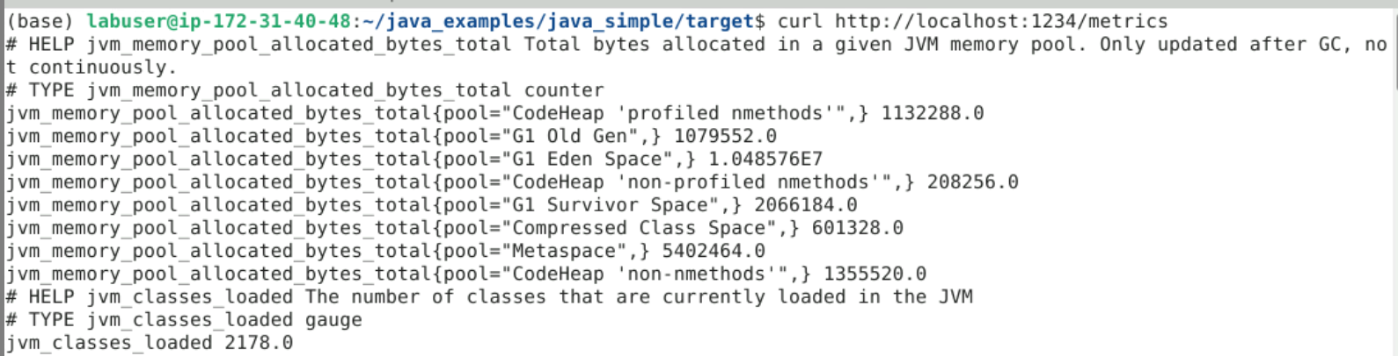

Stop Prometheus using sudo systemctl stop prometheus

In propetheus.yml file add following

- job_name: 'my-java-app'

metrics_path: '/metrics'

static_configs:

- targets: ['localhost:1234']

Start Prometheus using sudo systemctl start prometheus

Navigate to <http://localhost:9090/classic/targets>, will show the java application

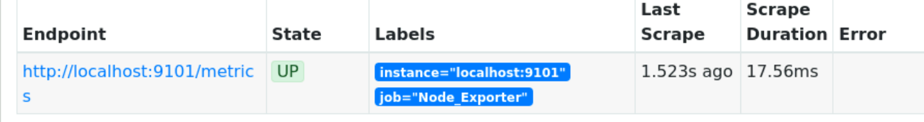

On navigating to <http://localhost:9090/classic/graph>

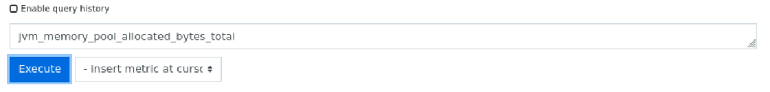

Will show all JVM options since the application is exposed to show all JVM options

Clicking

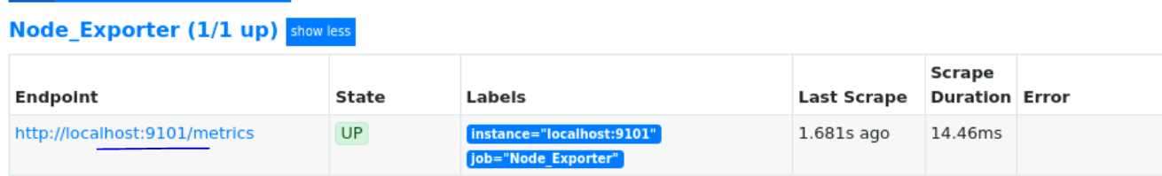

Will show all the options

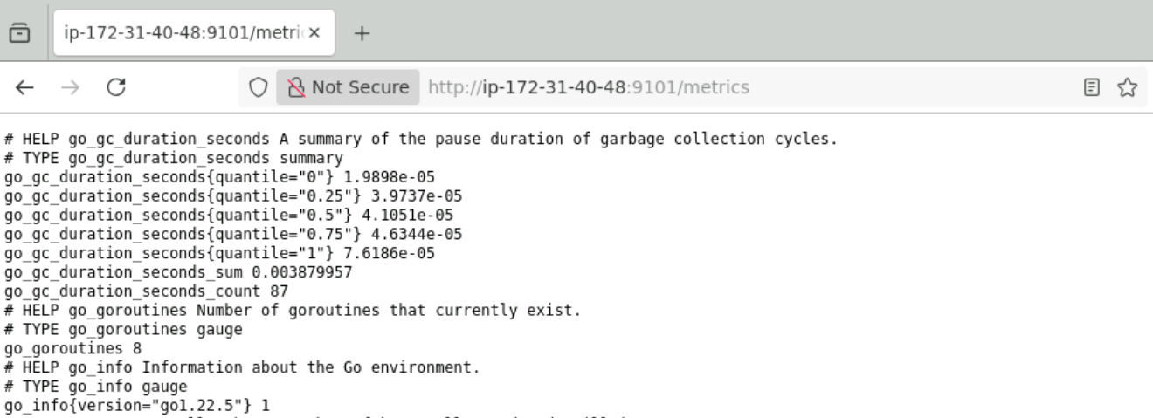

## Alert Manager

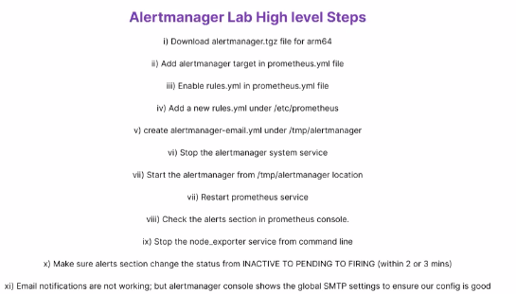

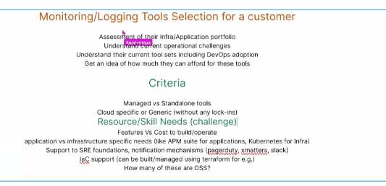

# Grafana

<https://github.com/devopscert202/monitoringlogging/blob/main/intro_to_grafana.md>

<https://www.onemodel.app/d/LT3woBf1udw4S1Ze8jz5f>

<https://github.com/rfmoz/grafana-dashboards>

Grafana supports elastic search, influx db but goes well with Prometheus

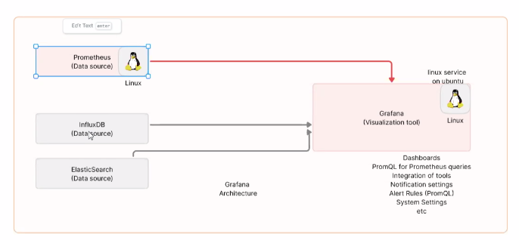

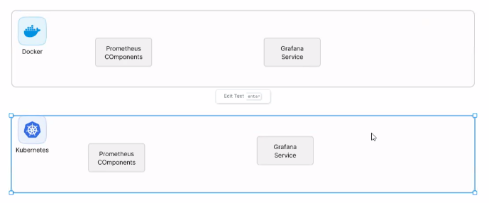

See around 9.30 and 10.30

### Install Prometheus and Grafanna – Docker

sudo netstat -anp | grep 8080

udo systemctl stop prometheus-node-exporter

sudo systemctl stop jenkins

sudo systemctl stop prometheus

sudo systemctl stop grafana-server

sudo systemctl stop alertmanager

### ELK Stack Logging

<https://github.com/devopscert202/monitoringlogging/tree/main/elkstack>

Start from <https://github.com/devopscert202/monitoringlogging/blob/main/elkstack/intro_elk.md>

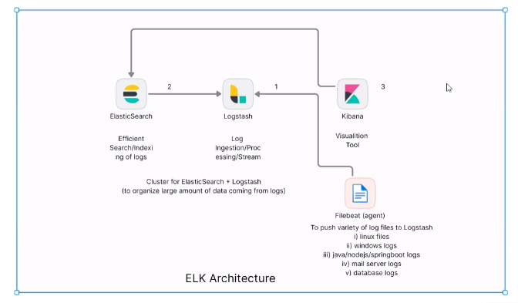

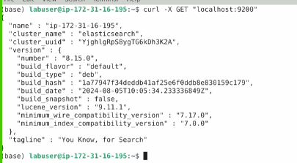

D:\Tutorials\Simplilearn\01 - DevOps Engineer\05 Monitoring and Logging in DevOps\Practice\Assisted Practice\Lesson_05_Centralized_Logging_and_Monitoring\05_Building_an_Automated_Log_Processing_Pipeline_with_Kafka_and_ELK_Stack

See between 8.30 to 9.15 PM

<https://github.com/devopscert202/monitoringlogging/tree/main/projects>

Project 2 - look on sample log file for node js from internet.

Kill a process

sudo lsof -i:9090

gives list of pids and kill the pid

